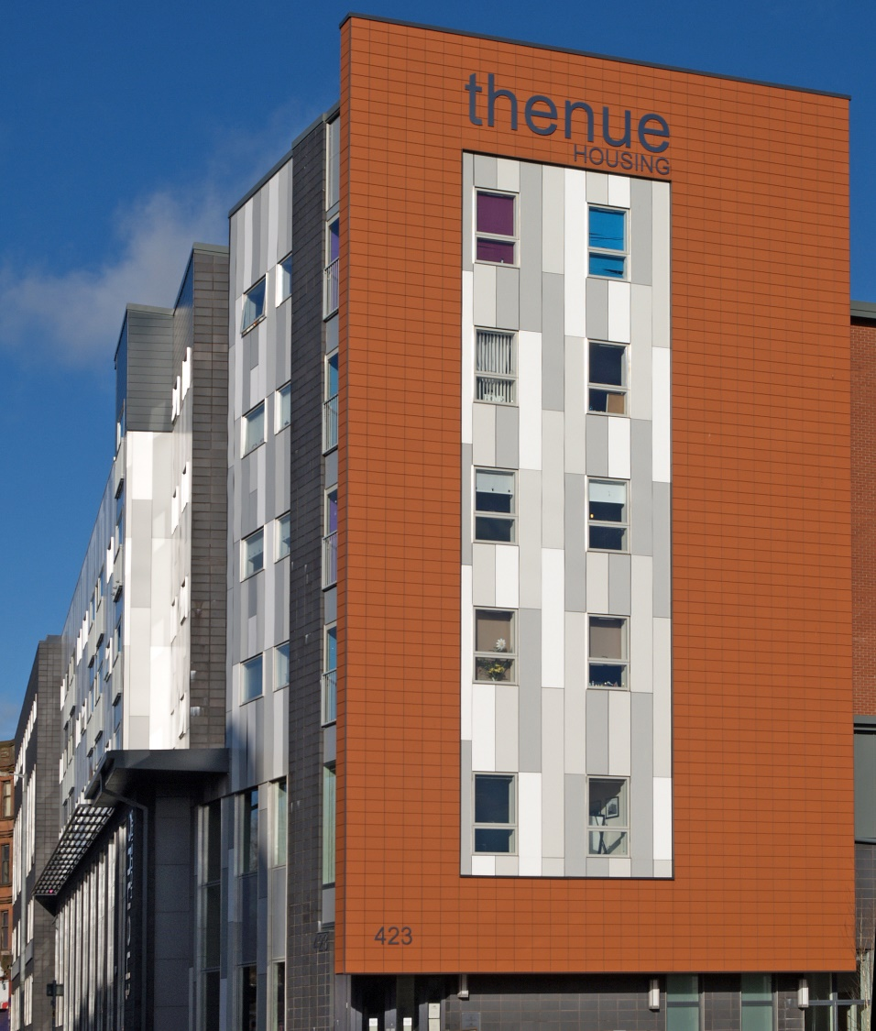

BURSARY SCHEME
APPLICATION FORM

Applications open on Friday 22nd March 2019 and close on Friday 10th May 2019 at 4pm
Helpful information about the Community Bursary
Why is there a Thenue Housing community bursary? We have developed a community bursary as part of our 40th Anniversary celebrations. This bursary will directly invest in local people to support them to achieve their educational aspirations. In order to do so, we will offer up to £1,000 for Higher Education/Further Education course(s), up to £750 for skills specific training and up to £500 for purchase of equipment, books and/or materials.
What is a bursary? This bursary is a one off sum that you are not expected to pay back. In return we do ask that the successful applicant meets with a staff member of Thenue Housing to hear about the range of ways to get involved in the Association.
What can the bursary be used for? We expect the bursary to be used to support you to complete an educational course. Examples include: a laptop, textbooks. Stationery, bus pass, course resources, childcare etc.
Will the bursary affect applications for SAAS or benefit payments? Receiving a Thenue Housing bursary should not affect a student’s entitlement to SAAS funding or benefit payments as it is a charitable donation. If you have queries regarding this we advise you to speak to the relevant agencies.
Who decides if my application is successful? The Community Bursary Panel (made up of Lynne McKenzie-Juetten, Corporate Services Manager and Ruth Adam, Community Regeneration Manager) are responsible for the administration of this bursary and make the final decision on who receives it.
Can I get help completing the form? Yes, please contact us on 0141 550 3581 or call into our office at 423 London Road.
Who can apply for the Community Bursary?
To be eligible for the community bursary you must meet all of the following criteria:
- You must not have received a bursary from Thenue Housing in the past
- You must be a current tenant of Thenue (or living with one of our tenants) or a factored owner of Thenue and have been accepted in to higher or further education for example college or university degree course
- You must be aged 16 or over
- You must not be an immediate relative of anyone who is employed by Thenue Housing (or its subsidiaries), by immediate relative we mean parent, spouse, child or sibling.
- You must have an account under your own name suitable for the funds to be paid in to (e.g. bank, building society, credit union)
- You must be able to provide the following to support your application:
  - A copy of your acceptance letter from the college or university
  - Evidence of your current residency
  - A reference from someone telling us why you should receive this bursary. This cannot be a family member, friend, or anyone employed by Thenue Housing (or its subsidiaries). You could use, for example, a previous teacher, your GP, an organisation you volunteer with, a religious leader, a youth or community worker. This reference must contain full name, address and contact details.
Part One: Your Personal and Contact Details
Surname
First Name(s)
Date of Birth
Home Address and Postcode
Telephone Number
Email Address

Are you currently in education? Yes/No (please circle your answer)
If yes, Where? ____________________________________________

Part Two: About Your Course
What is the full title of your course?
What is the name of the college or university you will attend?
Is it a full or part-time course?
When do you begin your course?
When do you expect to finish your course?
What do you wish to achieve from completing this course?
Part Three: Your Personal Statement
Use this space to tell us why you are seeking the bursary. You may choose to tell the panel what you would do with the funds, why you should receive this bursary and anything else about yourself that you might want us to consider

Please continue on a blank sheet of paper if necessary
Part Four: Declaration and Agreements
Please consider the statements below and tick the boxes to indicate your agreement
Please Tick
I declare that the information I have given is complete and accurate to the best of my knowledge and belief
I will inform Thenue Housing immediately if my circumstances change that might affect my eligibility to the bursary
I agree to provide additional information to support and validate my application if requested
I authorise Thenue Housing to seek confirmation of the validity of any of the information given in this application
I accept that any misleading or incorrect information may render this application void
I agree to provide relevant information on request about the use of the bursary (for example, details on what was bought, how it benefited you)
I agree to be contacted if my application is successful for a follow up chat that may be used in Thenue’s newsletter, website or social media pages

Please tick the box to let us know if you are happy for us to contact you in the future regarding other potential opportunities

Your Signature: _____________________________ Date _______________

We are committed to ensuring the secure and safe management of data held by us in relation to our customers, staff and other individuals, to find out more about this please refer to the Privacy Policy on our website or contact us for more information.
Please return this form by email to: lynne.mckenzie-juetten@thenuehousing.co.uk
If you have any questions or require support with your application, you can contact us by calling 0141 550 3581 or by emailing admin@thenuehousing.co.uk
Thank you for applying for our community bursary. If you have been successful you will receive a letter from the Community Bursary Panel by Friday 27th May 2019

