

PLEASE FILL IN THE FORM USING A BALL POINT PEN AND RETURN TO THE ADDRESS OVERLEAF →

Instruction to your Bank or Building Society to pay by Direct Debit.
→
allpay Limited Re:
Thenue Housing Association Limited Fortis et Fides
Whitestone Business Park Whitestone
Hereford. HR1 3SE

Service User Number

8 | 4 | 0 | 7 | 5 | 8

Name(s) of Account Holder(s).
Please complete your Address and Telephone Number.
This is not part of the instruction to your Bank or Building Society.
For allpay Limited Re: Thenue H A official use only.
Address:
Postcode:
Telephone: Ref:

Bank/Building Society Account Number.

Branch Sort Code.

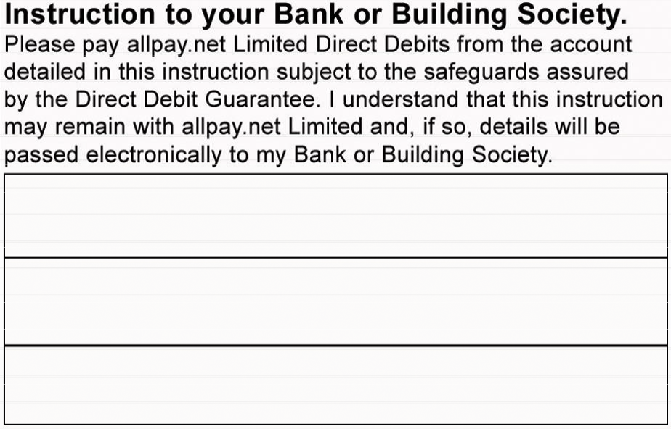Name & full postal Address of your Bank or Building Society.
Instruction to your Bank or Building Society
Please pay allpay Limited Re: Thenue H A Direct Debits from the account detailed in this instruction subject to the safeguards assured by the Direct Debit Guarantee.
I understand that this instruction may remain with allpay Limited Re: Thenue H A and, if so, details will be passed electronically to my Bank or Building Society.
Signature(s)
Date

To: The Manager Bank/Building Society
Address
Postcode
Reference

T | H | E | N
Banks and Building Societies may not accept Direct Debit Instructions on some types of Account.

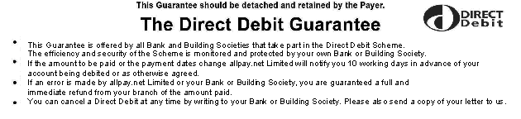

- This Guarantee is offered by all banks and building societies that accept instructions to pay Direct Debits.
- If there are any changes to the amount, date or frequency of your Direct Debit, allpay Limited Re: Thenue H A will notify you 10 working days in advance of your account being debited or as otherwise agreed. If you request allpay Limited Re: Thenue H A to collect a payment, confirmation of the amount and date will be given to you at the time of the request.
- If an error is made in the payment of your Direct Debit by allpay Limited Re: Thenue H A or your bank or building society you are entitled to a full and immediate refund of the amount paid from your bank or building society.
-If you receive a refund you are not entitled to, you must pay it back when allpay Limited Re: Thenue H A asks you to.
- You can cancel a Direct Debit at any time by simply contacting your bank or building society. Written confirmation may be required. Please also notify us.

Direct Debit Payment Details

Reference number
1st Payment Amount | Date of 1st Payment
Subsequent Payments | Next Due Date
Frequency of Payment
Service Centre (if applicable)
Date of entry onto Webconnect
Please enter the details of the customer, if different from those of the bill payer overleaf:
Name
Address
Post Code

PLEASE RETURN TO:

Payments will be collected on behalf of :

THENUE HOUSING ASSOCIATION LIMITED 423 LONDON ROAD
GLASGOW G40 1AG

