
Working with Us
Becoming a member of Thenue

Who can join?

If you live, work or have some other interest in the geographical area in which the Association works or otherwise interested in the activities of the Association or organisations who hold a share in the Association and whose names are entered in the Register of Members.
Thenue tenants Service users of the Association Other persons who support the objects of the Association
Organisations sympathetic to the objects of the Association

What can you do?
Attend the annual general meeting and any other general meeting of the association Elect the Board of Management
Stand for election to the Board of Management Appoint auditors
Receive, upon request, copies of any of the association’s policies and procedures or other appropriate information
How do I join?
Complete the application form and send it to our office Pay £1 to our office
Wait for confirmation that the Board of Management has approved your application, then you will be sent a share certificate and a copy of the rule book
What happens next?
Decisions about membership are made by the Board of Management and payment of £1 at that time. If your application is successful, you will become a Shareholder and a certificate will be issued.

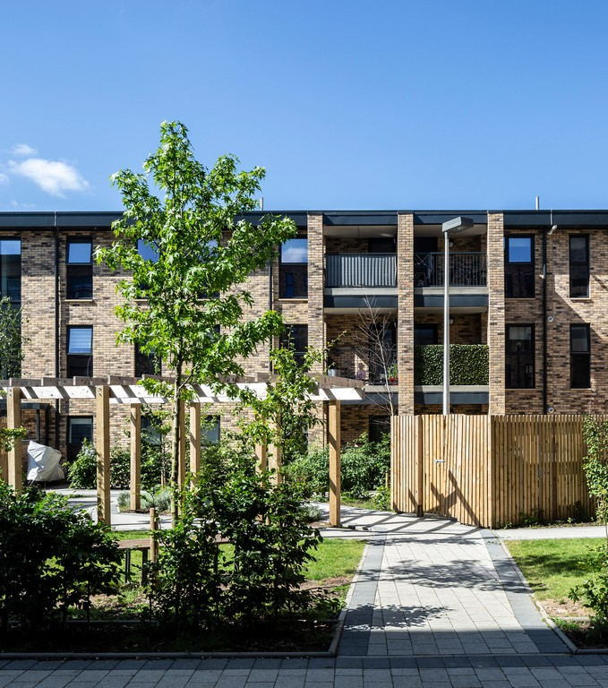
Full details of Thenue’s membership policy and procedures are available from our offices or our website.

Thenue Housing Association Ltd is a Registered Social Landlord. We are a registered society under the Co-operative and Community Benefit Societies Act 2014 and a Scottish Charity. If you would like to apply to become a Member, please complete this form and send it to: People & Culture Officer, Thenue Housing Association Ltd, 423 London Road, Glasgow, G40 1AG. The board will discuss your application and a
£1 Share Fee will be payable.




For official use only: Client No:
I apply to become a member of Thenue Housing Association Ltd,
and will pay £1 as payment for a Share.
Signed Click or tap here to enter text.
Date Click or tap here to enter text.
Share Certificate No:
£1 received:
Date Approved by Board of Management:
Membership Form

Full Name | Click or tap here to enter text.
Address | Click or tap here to enter text.
Post Code | Click or tap here to enter text.
Occupation | Click or tap here to enter text.
Date of Birth | Click or tap here to enter text.
E-Mail | Click or tap here to enter text.
Telephone | Click or tap here to enter text.

Preferred Method of Contact | Click or tap here to enter text.

Are you a tenant of Thenue? Yes ☐ No ☐

Are you a member of any other housing association Yes ☐ No ☐
or Cooperative. (If yes please state which)

Why do you want to become a member of Thenue? | Click or tap here to enter text.

